The Daily Fortune
Knowledge is power
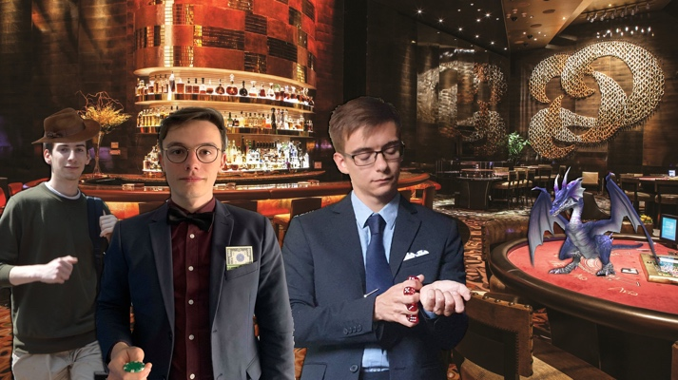  First picture of founders found in the underground passage ways.    Ivan Meuris  May the 15th  At the closing of the old passage ways that were used to smuggle drugs through the city, researchers found something very peculiar. Elon Mouse, head of the department of Fortunian researchers states that there has been found a picture of the founders of our state. This is the first time we ever get to see a picture where the three of them are at one place. What shocks us more is that there’s a dragon inside the casino they’re at. Nowadays dragons are not allowed to be inside buildings. More research will be needed to find out when this picture was taken and why the three founders where together at that moment. No matter what happens, we’ll keep you updated!  Grand new opening of the Magical Casino! |  |   3 Santarcticans dead after  shooting in illegal casino
  Jens Coopman  May the 15th  On the night of Tuesday to Wednesday, three Santarctican tourists died while visiting one of the illegal casino’s in Ventura, owned by Pueblo Escobluff. Escobluff is an infamous criminal in Fortuna and is one of the higher-ranking mobs amongst The Unfortunates.  Fortunian authorities have been trying to detain this criminal for several years, but were never able to, due to lack of evidence. This incident, however, gave the Fortunian law enough ground to stand on, and to hold him accountable for the deaths of these 3 Santarctican individuals. |  | Santarctican and Fortunian authorities have already held an emergency meeting at the Santarctican embassy, located in Ventura. It is still not clear whether these tourists were killed or if they made a life-threatening bet, because the safety regulations are mostly inexistent in these illegal casinos.  From now on, new safety regulations will be put in place in order to keep tourists from entering these casino’s and travel agencies from all over the world will be informed about what establishments to avoid.  Fortuna’s leader has expressed his sincerest condolences to the families of the victims and is working around the clock to make sure Pueblo Escobluff doesn’t go unpunished for his crimes against Fortuna.
IN THIS ISSUE
Dragon that destroyed forest escaped from asylum |  | Moe Moneybags  wins the jackpot |  | New species of electrical mouse found

